Jenkins Installation with Deployment
Jenkins is one of the most popular tools for continuous integration and continuous delivery on any platform. A java application, Jenkins has many plugins for automating almost everything at the infrastructure level. The use of Jenkins has widely increased rapidly due to a rich set of functionalities, which it provides in the form of plugins. In this blog we will show a step by step guide of how to install Jenkins on a Windows platform.
First, you need to install JDK. Jenkins currently only supports JDK8. Once Java is running, you can install Jenkins.
- Click https://jenkins.io/download/ to download the latest Jenkins package for Windows (currently it is version 2.190).
- Unzip the file to a folder and click on the Jenkins exe file.
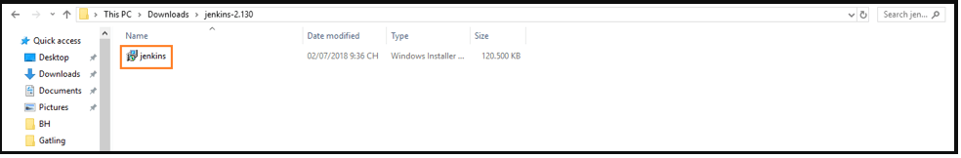
- Click “Next” to start the installation.
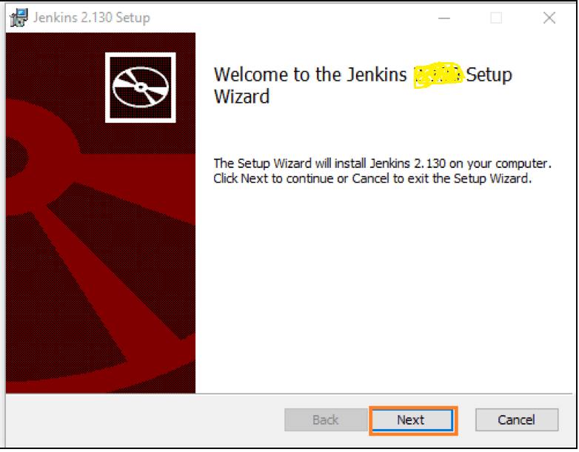
- Click the “Change…” button if you want to install Jenkins in another folder. In this example I will keep the default option and click on the “Next” button.
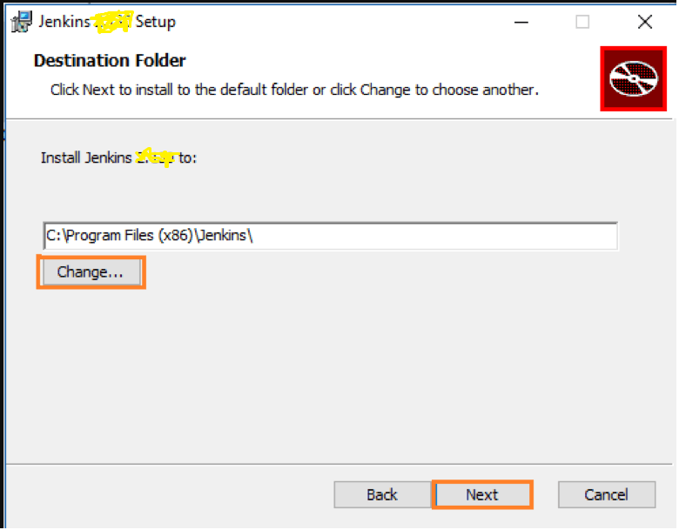
- Click the “Install” button to start the installation process.
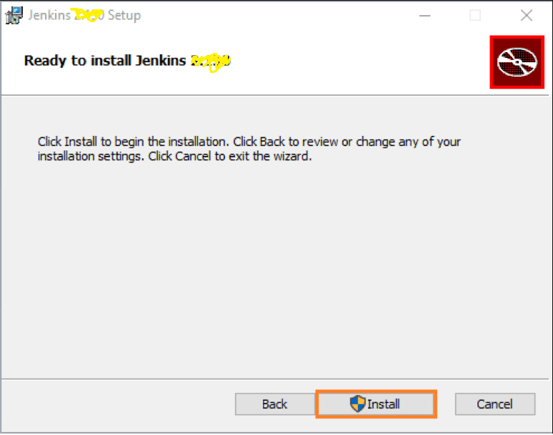
- The installation is processing
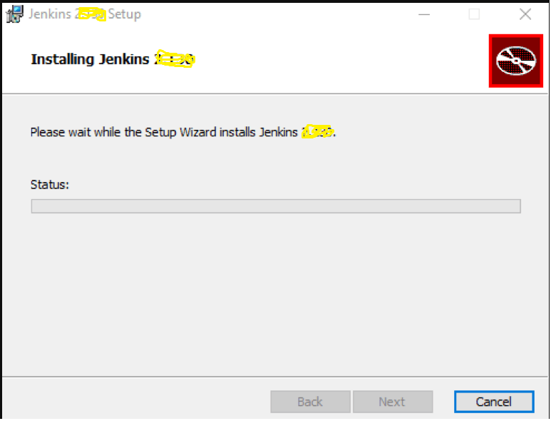
- When done, click the “Finish” button to complete the installation process.
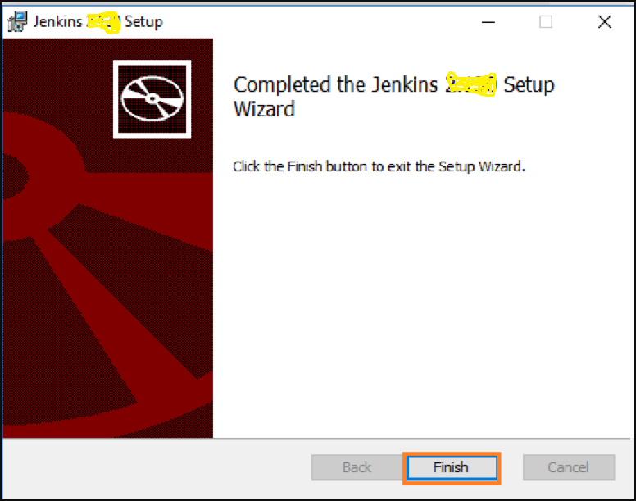
- You will automatically be redirected to a local Jenkins page, or you can paste the URL http://localhost:8080 in a browser.
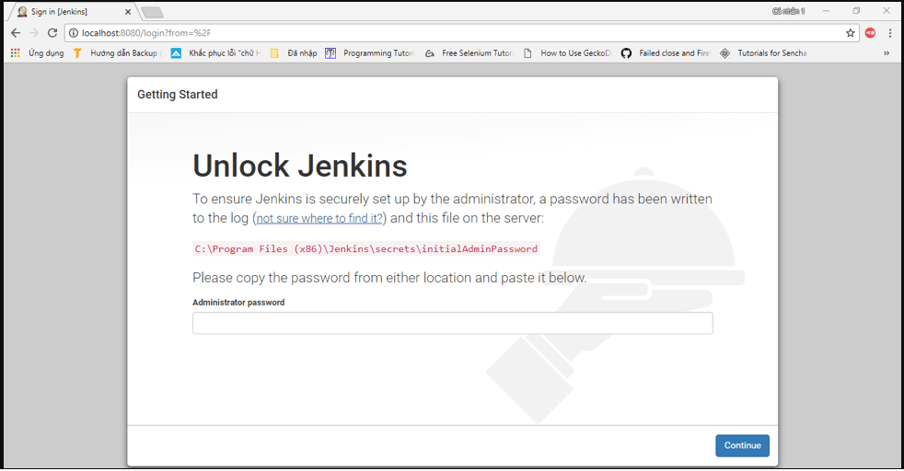
- To unlock Jenkins, copy the password from the file at C:\Program Files (x86)\Jenkins\secrets\initialAdminPassword and paste it in the Administrator password field. Then, click the “Continue” button.
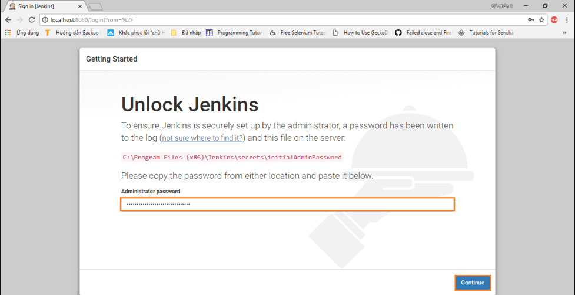
- You can install either the suggested plugins or selected plugins you choose. To keep it simple, we will install the suggested plugins.
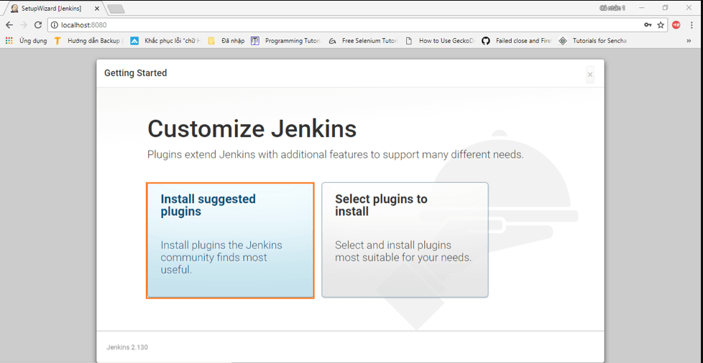
- Need to wait until the plugins are completely installed.
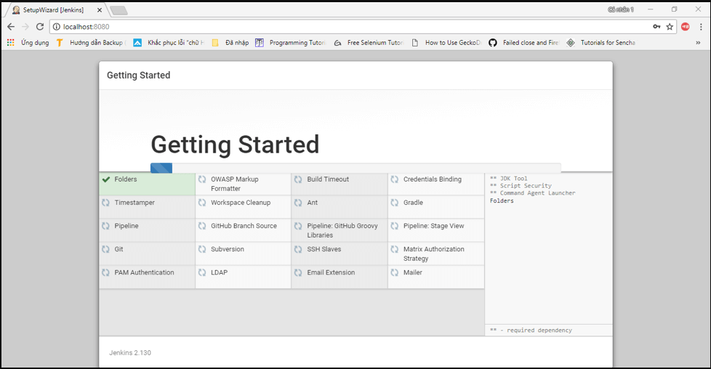
- The next thing we should do is create an admin user for Jenkins. Put in your details and click “Save and continue”.
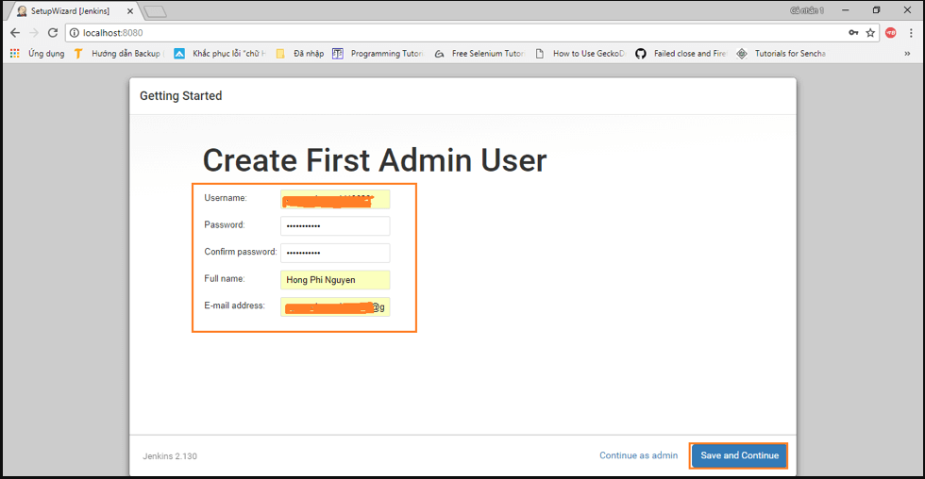
- Click “Save and Finish” to complete the Jenkins installation.
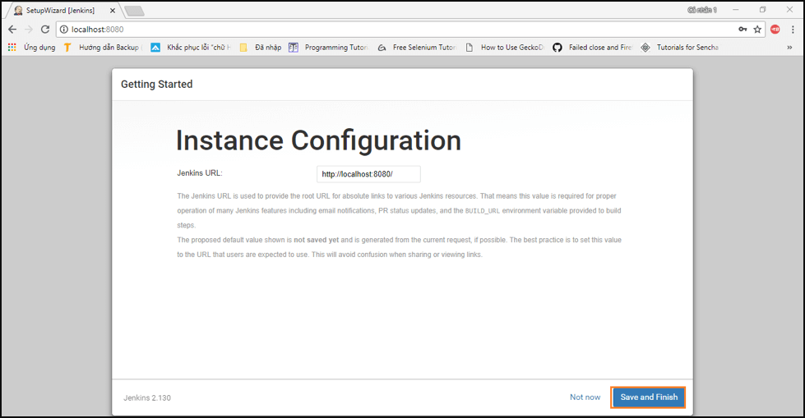
- Now, click “Start using Jenkins” to start Jenkins.
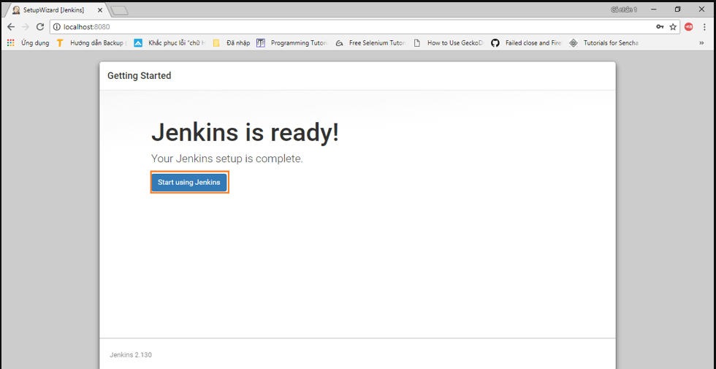
- Finally, here is the default Jenkins page
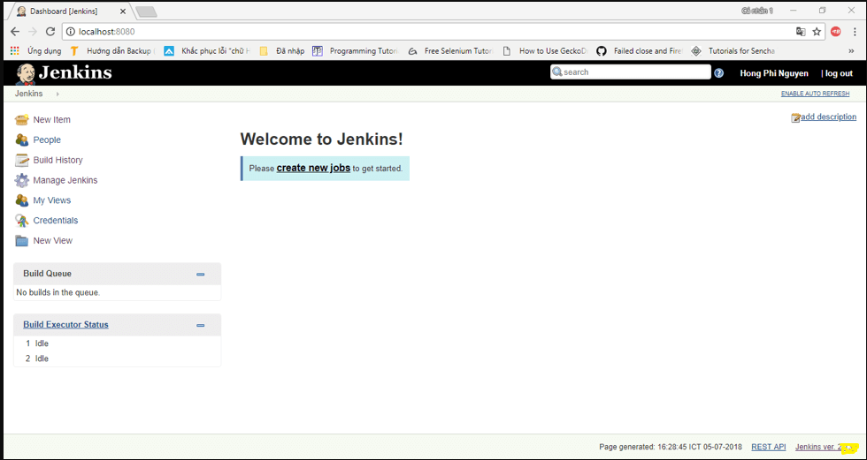

Configuring Jenkins for a Maven Project

- To configure Jenkins for a Maven project, load Jenkins and go to Manage Jenkins > Global Tool Configuration and setup all the properties as shown below.
- Maven/JDK installation and Git can be installed automatically by checking Install automatically. This will allow Jenkins to download the appropriate files needed.
  - JDK installations
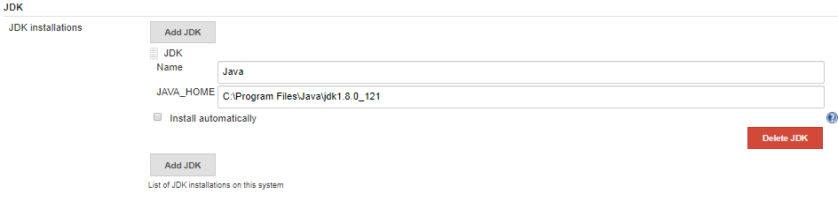
  - Git installations
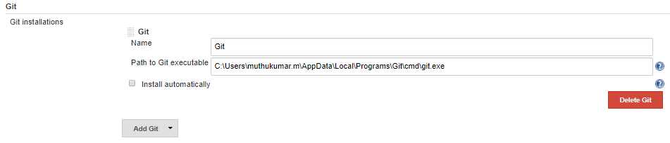
  - Maven installations
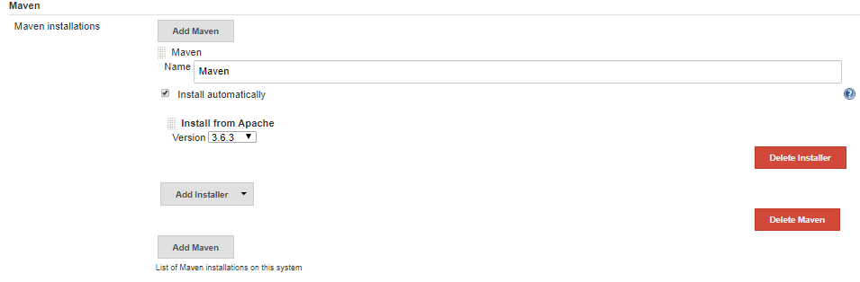
- Create a new Job by clicking New Item
- Enter your Job Name ‘JenkinsDemo’ and select Maven Project then click OK, You will be navigated to configure the Job.
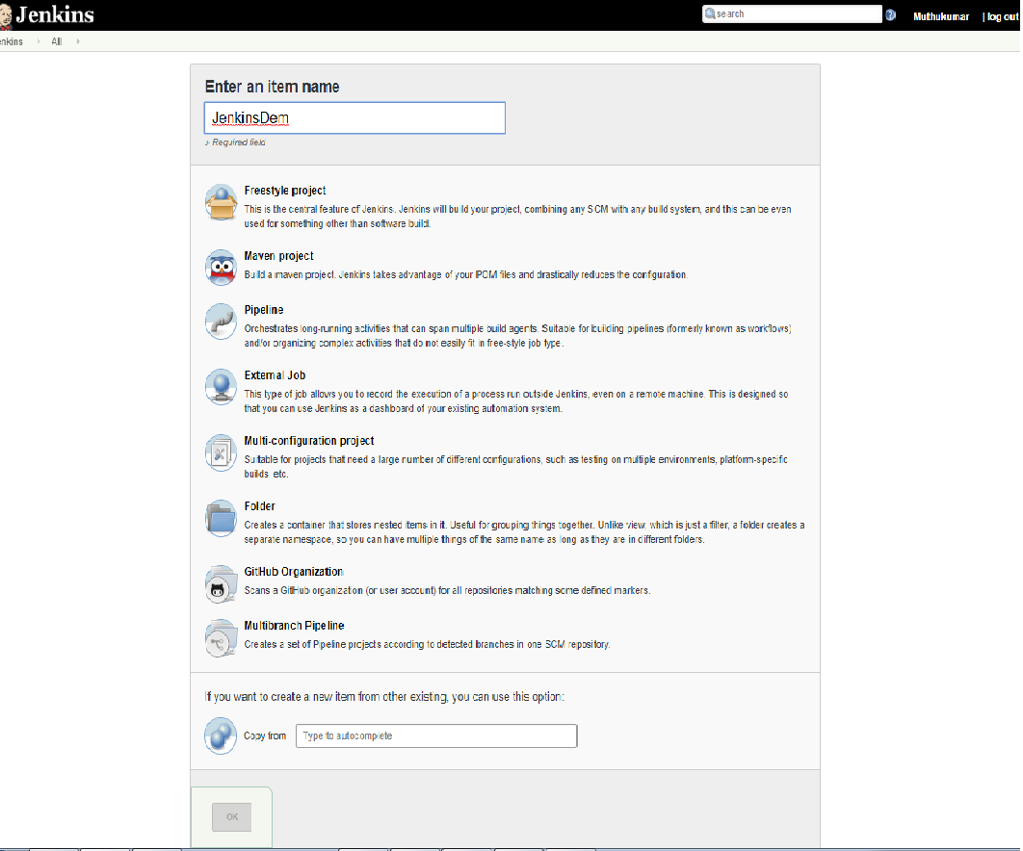
- If Maven Project is not visible in your Jenkins then install plugin named as ‘Maven Integration’
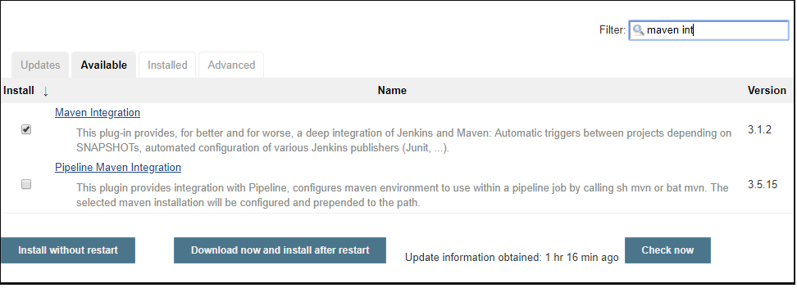
- In job configuration under General Section tick Github project and provide your project url from Github- https://github.com/JavaMuthu/JenkinsDemo.git this will provide you link to GitHub from Job dashboard and it is optional.
- Under Source Code Management section click on Git radio button and provide Repository URL- https://github.com/JavaMuthu/JenkinsDemo.git
- Select branch to build if master- ‘*/master’ if development- ‘*/development’.
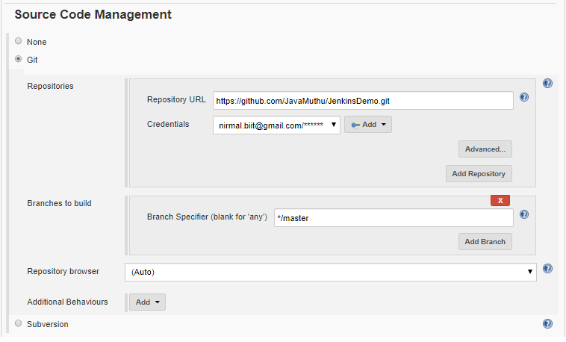
- Select build section to generate a maven build by using clean install.
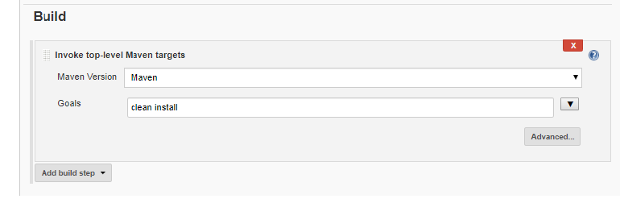

- Generate Post build Actions,
  - Archive the artifacts
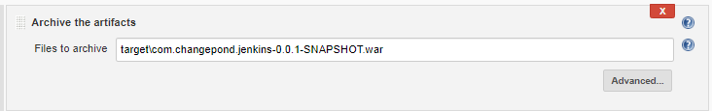
  - Post build task
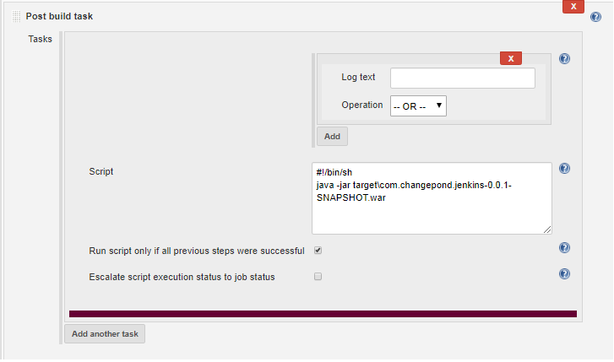
  - Publish JUnit test result report
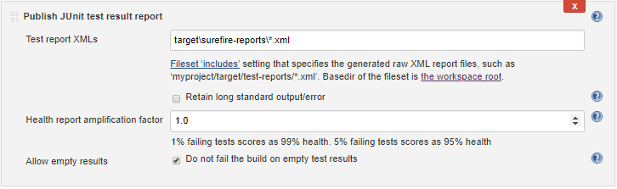

- Navigate to that project. You will have to click on Build Now.
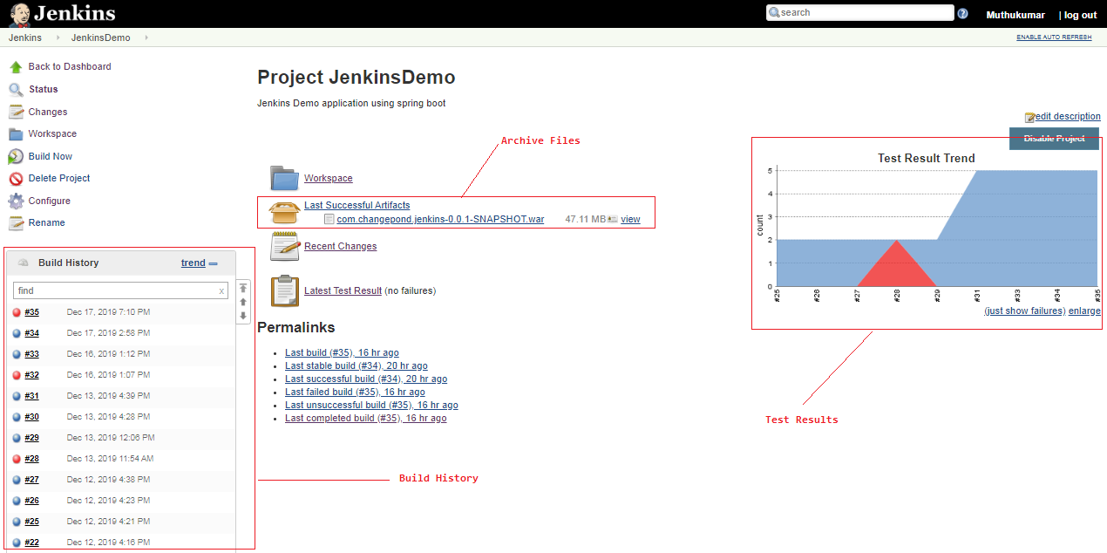

- If you want to logout Jenkins, please click on logout button action.
